Configuration of HyperV on Windows of VMs
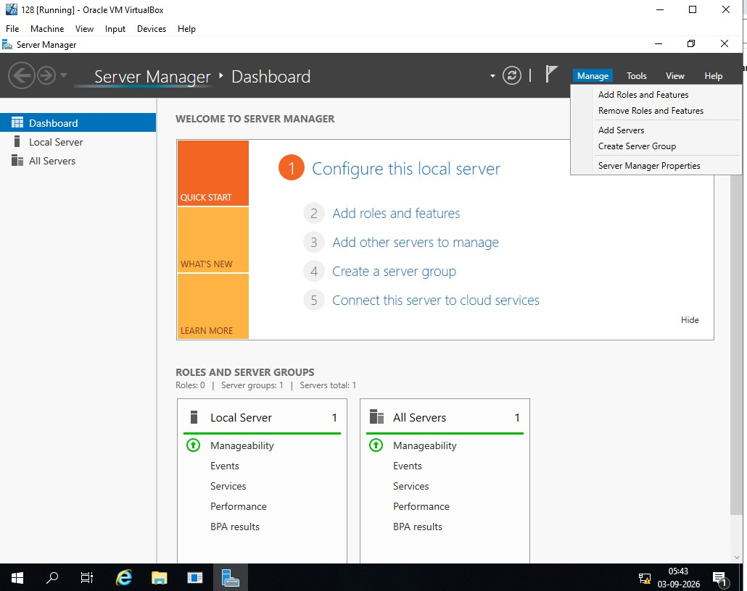
- Open the windows server and open the server manager Click add roles and features . Read before you begin and click next.
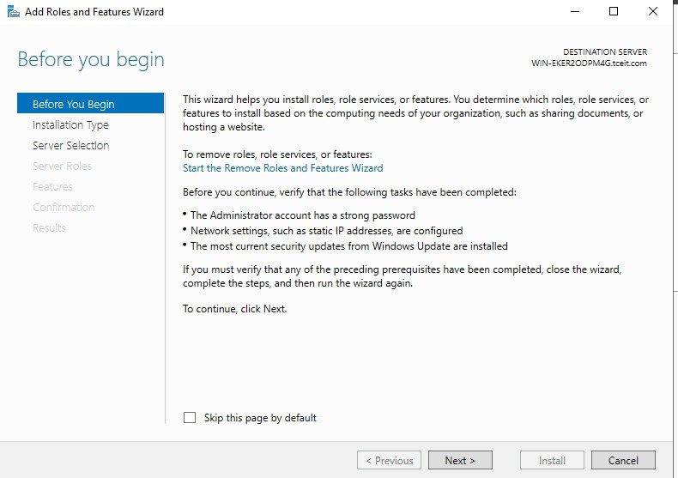

- Select role based installation type and click next.
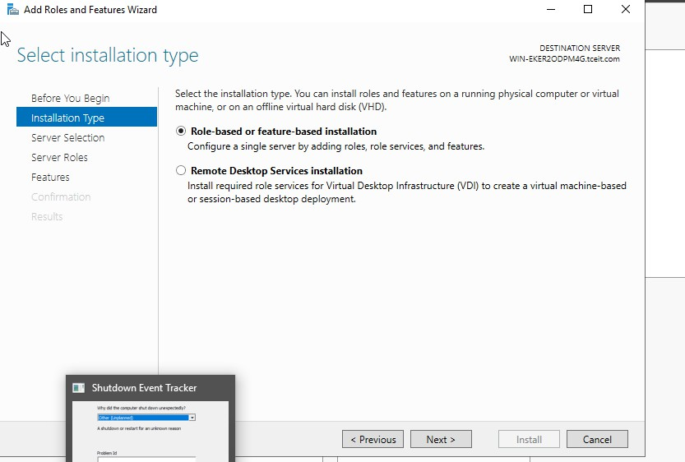
- Select the server and click next.
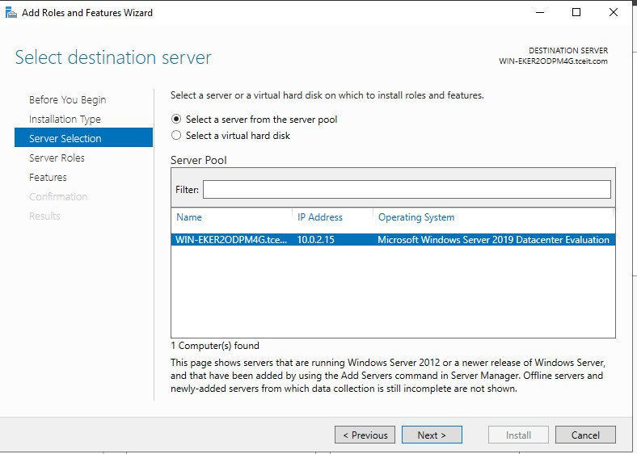
- In server roles .check on hyper v and click the add features .
- Enable virtual switches both ethernet and virtual box host only adapter
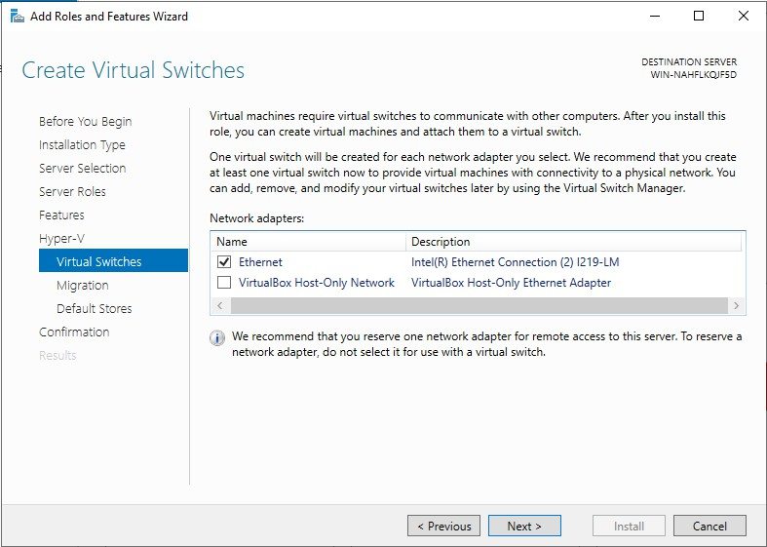
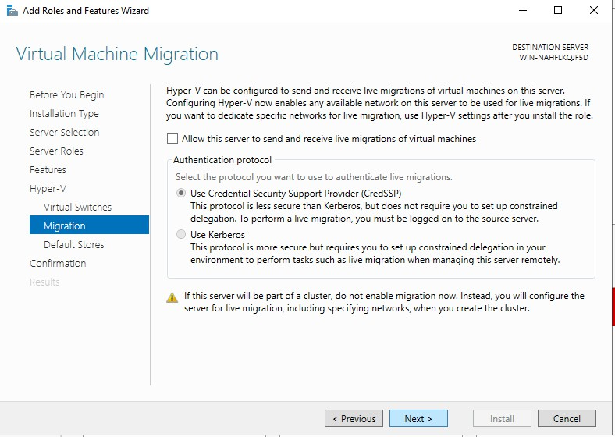
- For migration use credential security support provider.

- Click install and hyperv has been installed and enabled on the windows server.
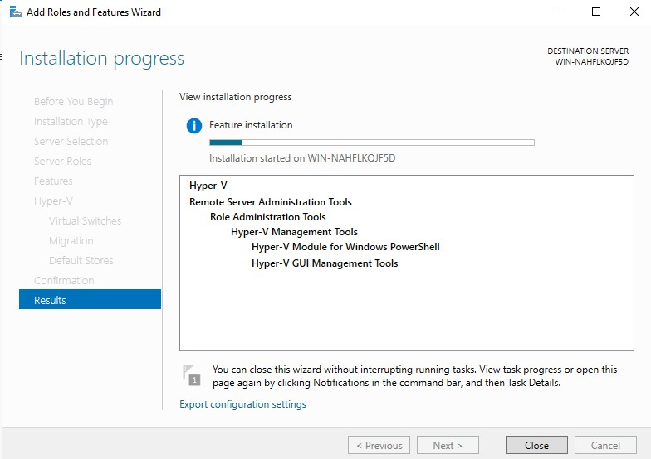
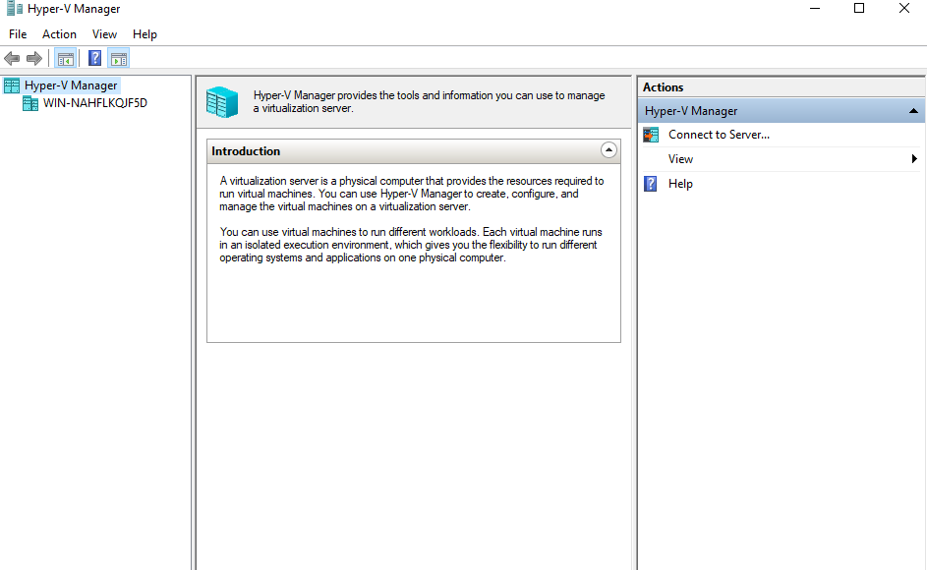

Creation of VM, Powershell commands, Management
- open Tools-> hyper v manager-> right click on server and click create new vm
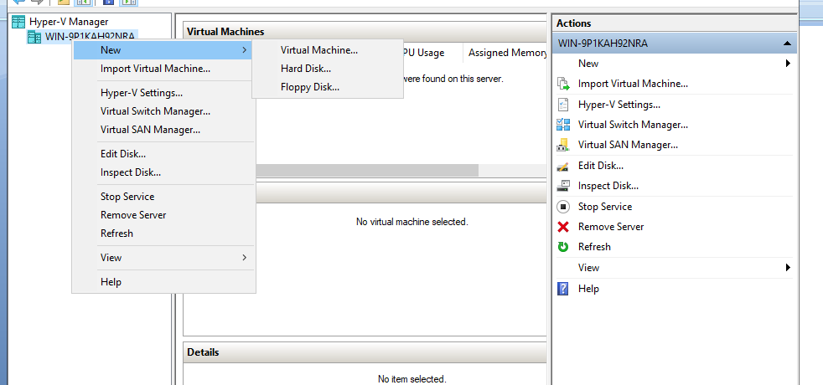
- Specify name and location click next.

- Assign the memory for the vm(for safety give as 2gb )
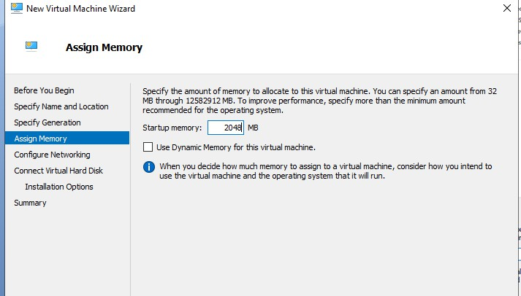
- Configure the network click on interR Ethernet connection virtual switch
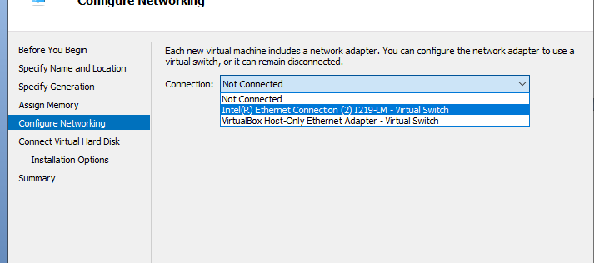
- Connect virtual harddisk (name,location,maximum gb) click next

- Import the iso file which os need to install on the vm(here ubunttu)
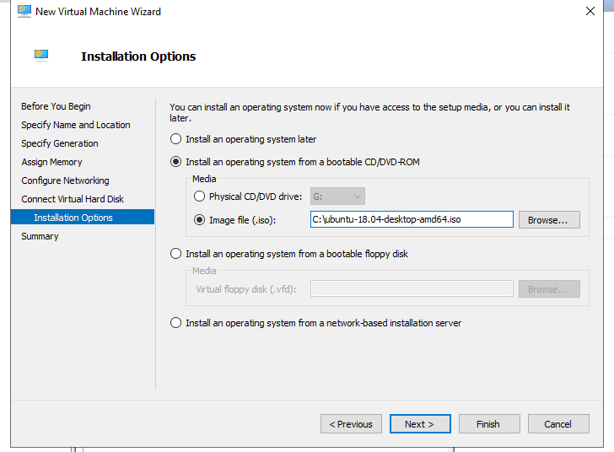
- Click finish

Vm installation using Powershell:

Procedure :

  - Create vm with name and space in gb with virtual hard disk creation
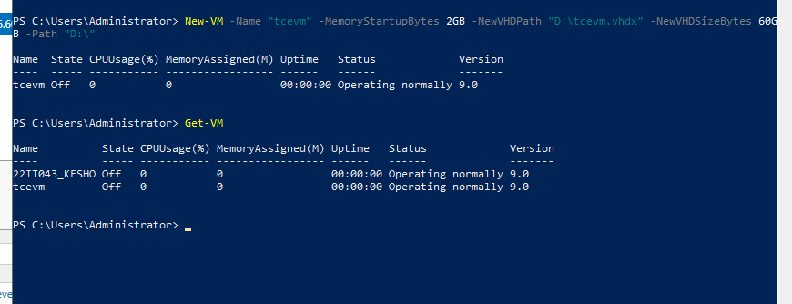

  - Asssign virtual switch to the vm
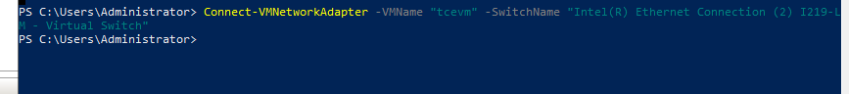

  - import the iso file which os need to install on vm
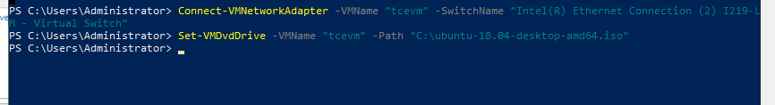

  - Start the vm
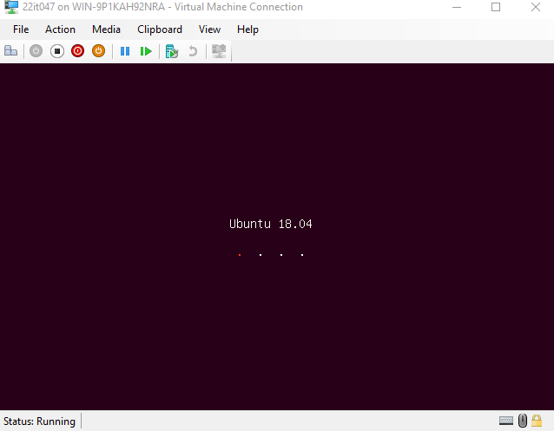
Powershell commands
- Get vm and start vm
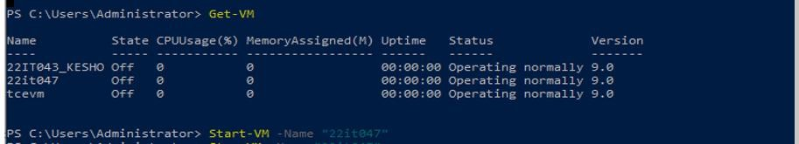

- Stop vm
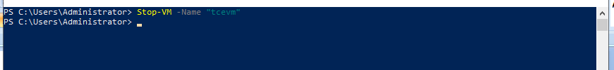

Migration(Right click the vm and click move) and give finish .
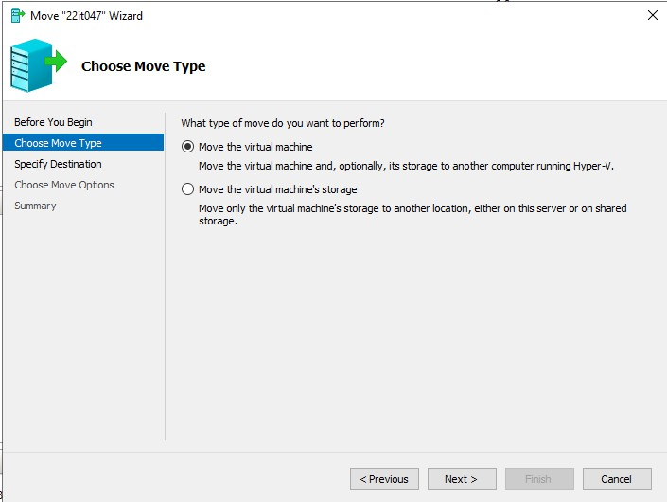

OPEN V SWITCH

- Check the current network configuration.
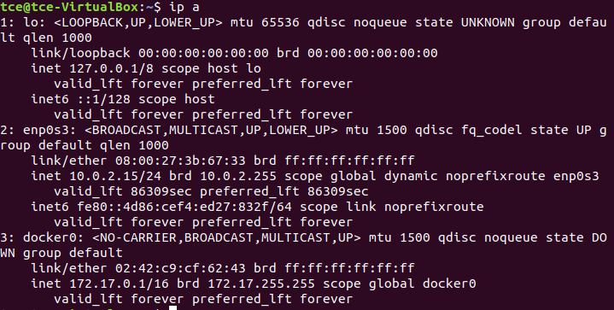
- Install and configure necessary Bridge Utilities
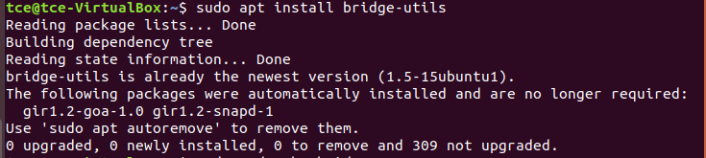

- Edit the netplan configuration file and specify the configuration.
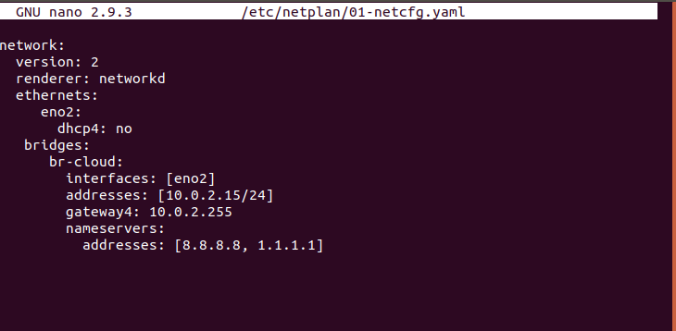

- Apply the new netplan configuration and restart the network.
- Verify the network interfaces and bridges.
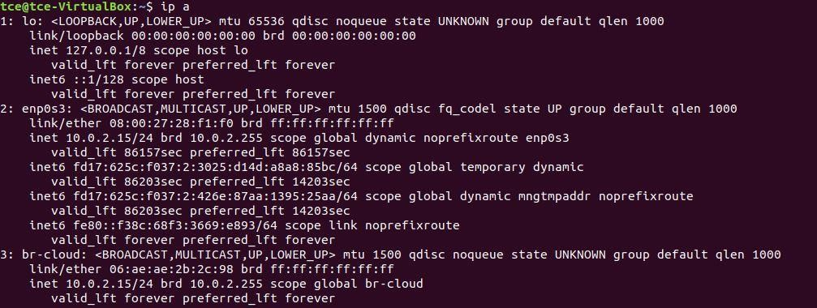
- Verify the routing table.
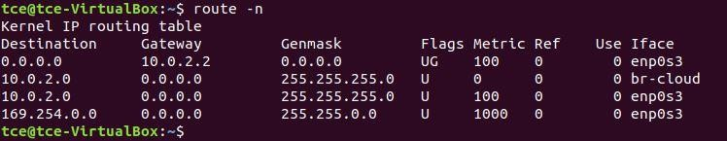
Open Virtual Switch (OpenVSwitch/OVS):
- Enter as root user.
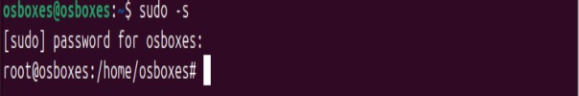
- Create 2 namespace (in my case VRF1 and VRF2).
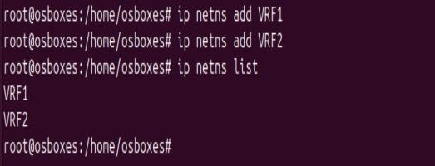
- Create 4 Virtual ethernet port to attach with bridge and namespaces.
- If the configuration is done to create the topology shown in the image, the links will be as
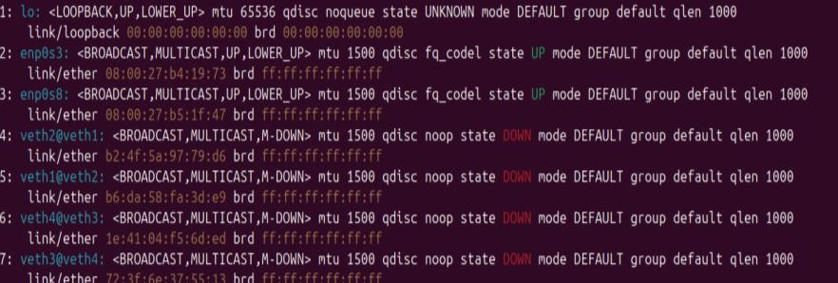
- Assign each virtual ethernet port to the particular namespace
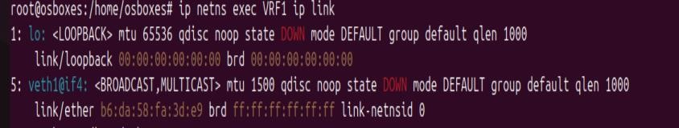
- Assign IP addresses to the virtual ethernet ports

- Check the configuration using the default routing table
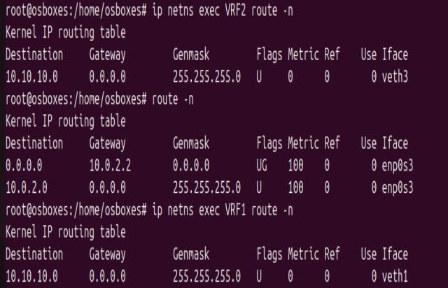
- Install openVswitch and its dependencies

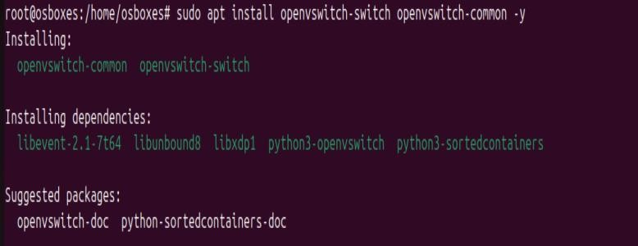
- Check the status of the openvswitch service, if off turn it on.
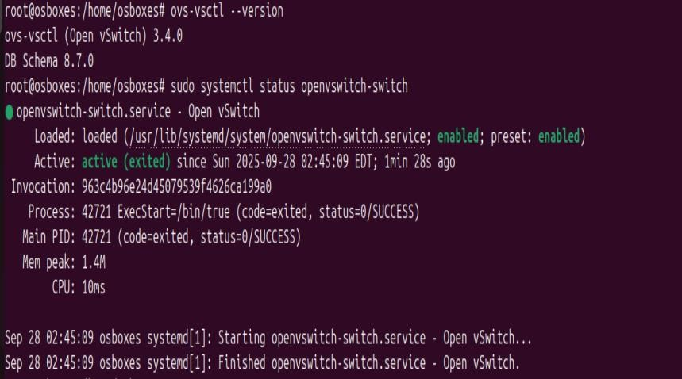
- Add the switch using ovs commandline tools and check the configuration
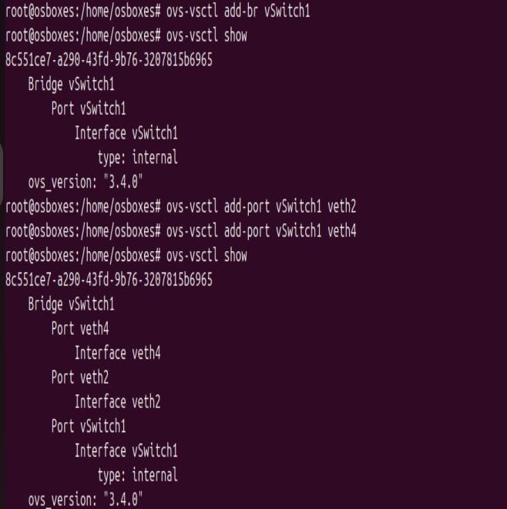
- Turn the virtual ethernet ports up and configure IP for switch check their status

- Ping the namespace at the other end, if the configuration is done correct we can ping the Virtual namespace 2 from virtual namespace 1 via the switch (ovs bridge)
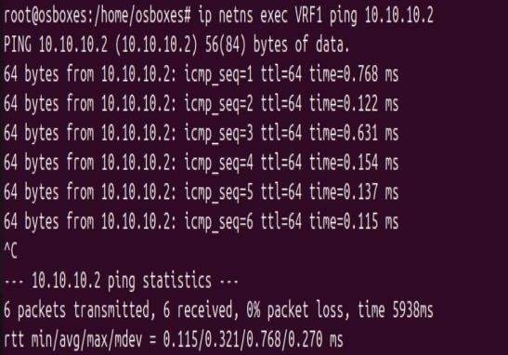
- Optionally you can turn on the spanning tree protocol (to prevent broadcast storms and network loops)
- Finally check the MAC address attached with the switch and the actual mac address of the virtual namespace device, if they match everything is done right.

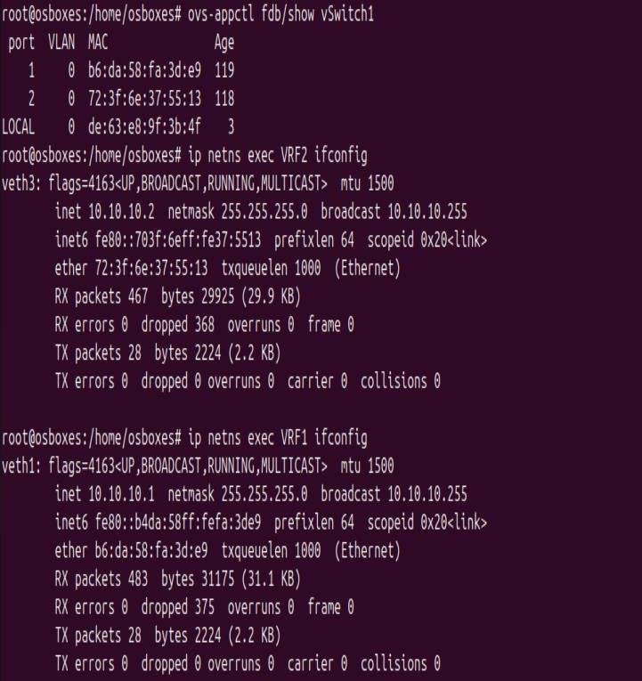

INSTALLATION OF OPENSTACK
- Update all the file in the ubunttu by sudo apt update
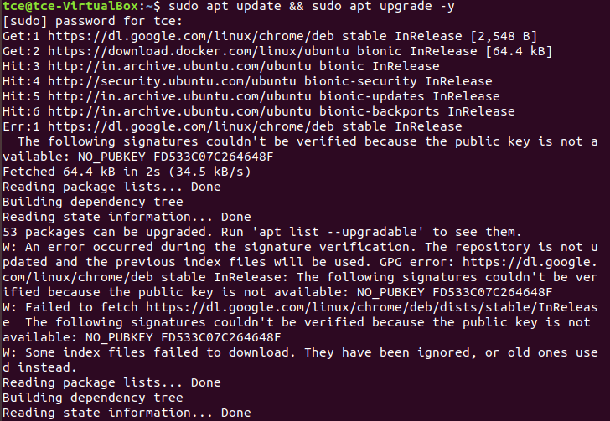
- Install the packages to build the openstack
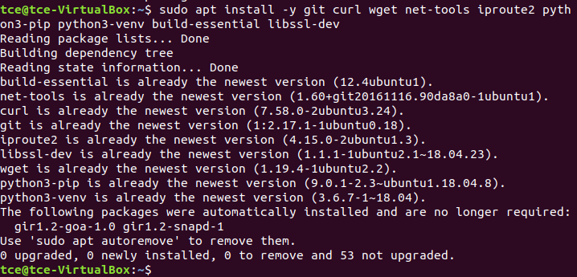

- Add the user stack to the ubunttu especially for the openstack and give the sudo privilege for the user stack and add to the group
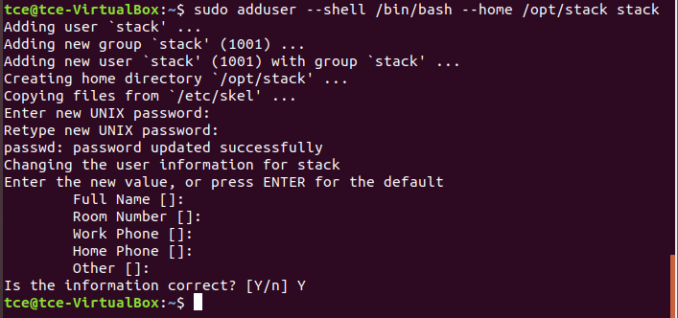

- Set no password for all
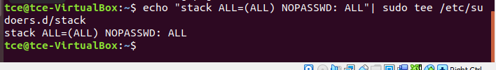

- Give the privileges for the user stack
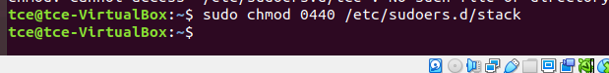

- open as sudo user by the command sudo su - stack
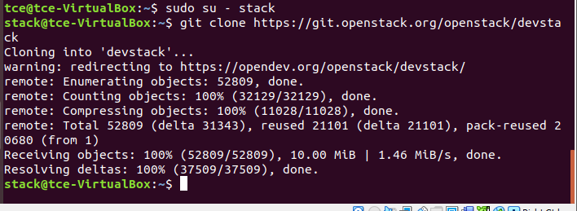
- go to home directory and download the openstack from the git by cloning the git .
- Move to the devstack directory.
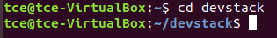

- Change the configuration file in the local.conf
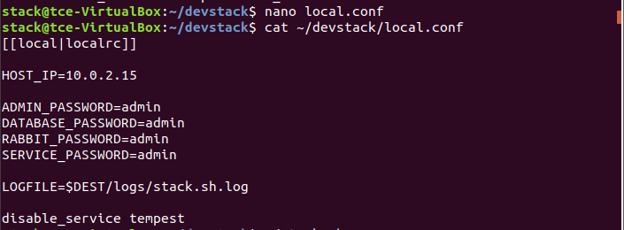
- Run the openstack by the ./stack.sh
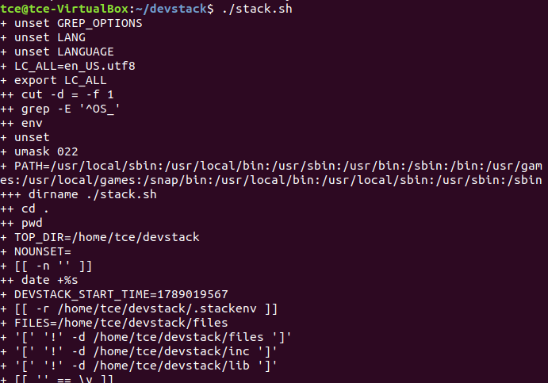

- Visit the IP address that you have configured in the local.conf and login with the password configured in the local.conf
